**Traditional Tales**

We will be looking closely at the different vocabulary used in traditional tales.

***Challenge:***

***Can you retell your story using the following words and phrases?***

***Once upon a time, long ago, suddenly, then, next, they all lived happily ever after, the end.***

After we have read one of our traditional tales, we will draw a story map to retell the story. Here is an example of a story map we drew for Goldilocks and the Three Bears.

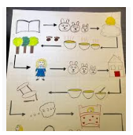

We are going to be reading lots of different traditional tales including Goldilocks and the Three Bears, Jack and the Beanstalk, The Gingerbread Man, Little Red Riding Hood and The Three Little Pigs.

We will also be acting these stories out, thinking about alternative endings and looking at alternative versions and comparing them to the originals.

***Challenge:***

***Can you visit your local library and see which traditional tales you can find to borrow and share at home?***

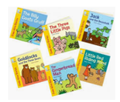

***Challenge:***

***Can you draw a story map of your favourite traditional tale?***

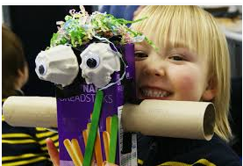

***Challenge:***

***Can you use recycled materials to make something new? A house for the three pigs, a chair/bed for Goldilocks etc***

We are going to exploring and using a variety of media and materials. The children will learn to safely use and explore a variety of materials, tools and techniques, experimenting with colour, design, texture, form and function. We will design our creations, make them and then look at different ways we can make our creations better.

**Please remember to upload any challenges completed at home to Tapestry. If your Tapestry account isn’t working or you are unsure how to upload to Tapestry please don’t hesitate to come into school and we will help in any way we can. Thank you for your continued support.**

***Challenge:***

***Can you paint characters from traditional tales? Can you mix some colours at home yourself? Can you learn which colours you can mix to make new colours?***

We are going to be exploring what happens when we mix colours together. We will mix and choose colours for a purpose

. 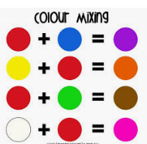

Your child is working hard in school to develop their reading skills. Please read each night and sign the yellow reading record to indicate when your child has read.

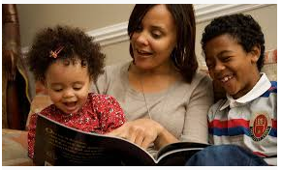

***Challenge:***

***Can you order different things around your house in size order? You could use sticks, teddies, dolls, cars shoes, spoons etc***

While we were reading the story of Goldilocks and the Three Bears we noticed that the bears, the bowls, the chairs and the beds were all different sizes; small, medium and large.

