Sea

**Science**

**Animals Including Humans**

**Key Vocabulary**

Atrium – The upper chambers of the heart.

Circulatory System – The system that controls the flow of blood around the body.

Deoxygenated – Not containing oxygen.

Oxygenated – Containing oxygen.

Ventricle – The lower chambers of the heart.

Vessel – Tube which circulates blood through the body.

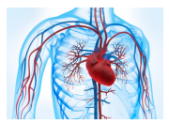

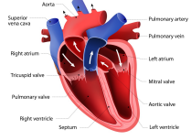

In Science we will investigate some key questions:

* What is the function of the heart?
* How does blood move through our bodies?
* What is in our blood?
* How are water and nutrients transported around our bodies?
* What affects our heart rate?
* What is the impact of drugs and alcohol on the human body?