**Polar Regions**

We will be naming and describing 2D shapes in our environment. E.g. objects that look like a circle, a square, a rectangle, a triangle.

***Challenge:***

***Can you name any 2D shapes you see on your journey to and from school?***

We will be reading both fiction and non-fiction books in this topic. Non-fiction books tell us facts about animals that live in the Polar Regions.

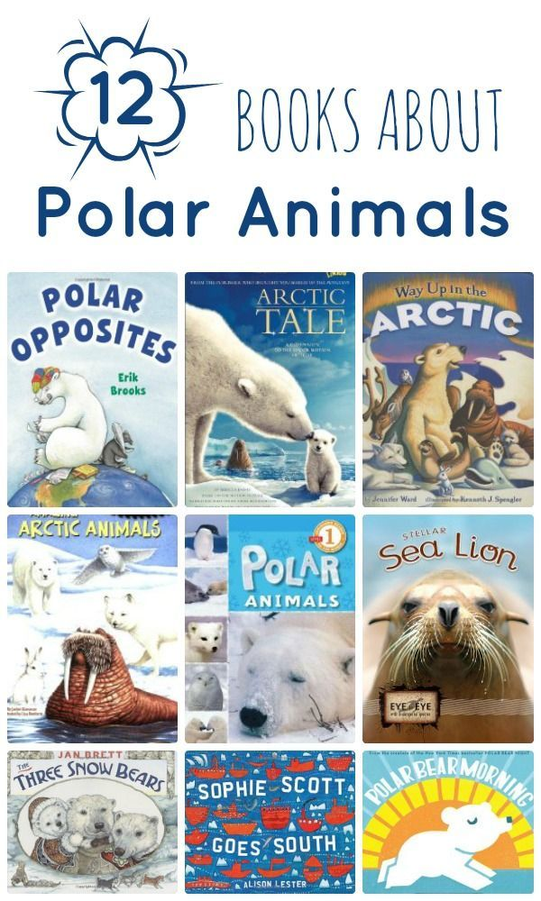

We will be reading lots of stories related to the topic of Polar Regions. We will be discussing descriptions of animals and people that live in the Polar Regions and what they do.

***Challenge:***

***Draw a picture of an animal or person who lives in the Polar Regions.***

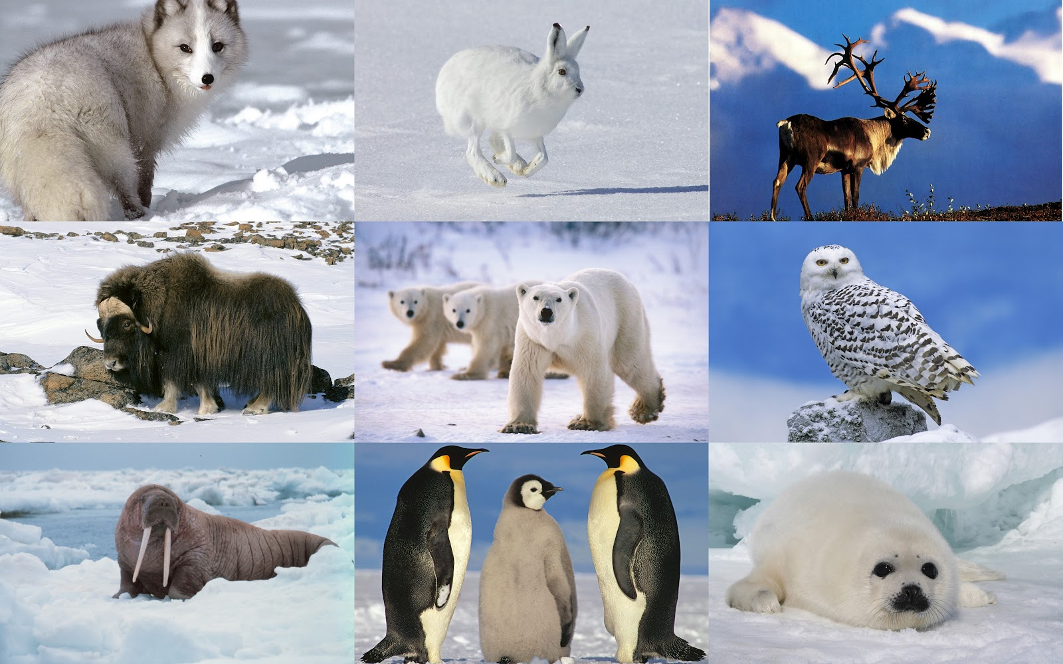

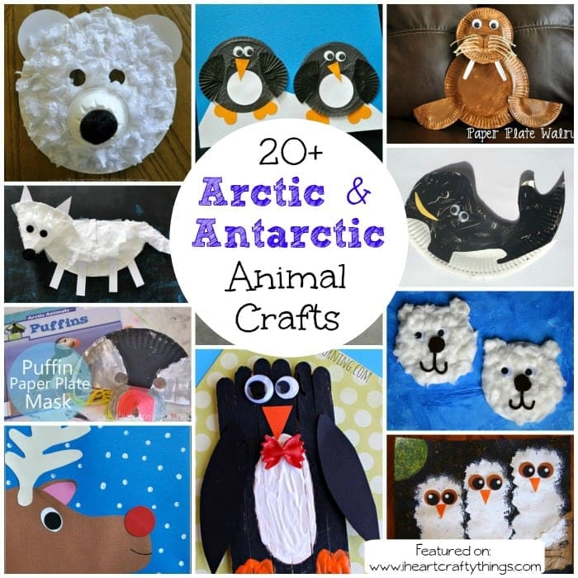

We are going to be exploring and using a variety of media and materials. The children will learn to safely use and explore a variety of materials, tools and techniques, experimenting with colour, design, texture, form and function.

***Challenge:***

***Can you remember a fact about one of the animals and tell someone you know?***

***Challenge:***

***Can you paint a picture or create a collage of your favourite polar animal? You could use different materials to create feathers or fur or add cotton wool for snow!***

In Phonics we are learning to blend. For example, c a t is cat, d o g is dog, p i g is pig.

***Challenge:***

***Can sound out simple 3 letter words for your child to blend together?***

***Challenge:***

***Can you mix some colours at home yourself? Can you learn which colours you can mix to make new colours?***

We are going to be exploring what happens when we mix colours together. We will mix and choose colours for a purpose

. 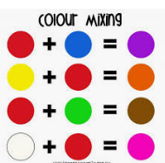

Please complete one challenge per week and upload pictures to Tapestry each week when you have completed this.

Please check Tapestry regularly for updates and extra learning activities for your child and post pictures of these.

Thank you for your support. 