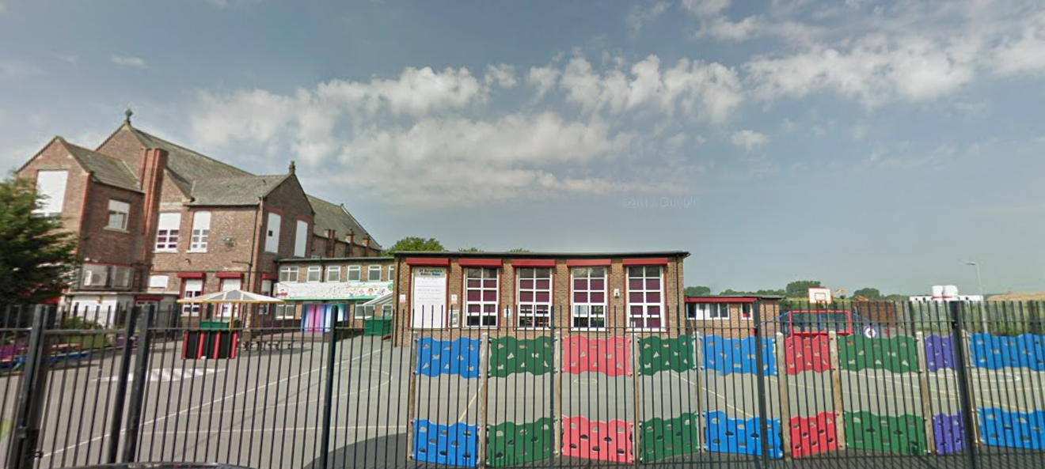

‘Keeping Christ at the heart of all we do’

**St. Sebastian’s R.C. Primary School**

**Curriculum Overview**

**Year 3 Spring**



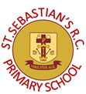

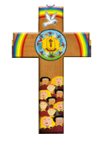

|  |  |
| --- | --- |
| **Class Information**  Spellings- spellings will be taught on Monday. The children will practise writing these each morning. They should complete a quiz on purple mash to practice them at home. They will be tested on Friday.  Homework-a piece of maths and English homework to consolidate the children’s knowledge, will be set on Friday to be handed in on Wednesday  Reading- regular reading at home is essential to build up your child’s vocabulary and pace. Please try to read for at least five minutes each evening and sign your child’s reading log.  Times tables- the rapid recall of multiplication facts is vital for accessing the mathematic curriculum. Regular practise at home is invaluable to prepare your child for lessons in school. The children all have their own login details to times table’s rock stars.  P.E- our P.E days are Mondays and Tuesdays , please make sure your child has the appropriate shorts, t-shirt and foot wear. | |
| **English** | **Narrative:**  We will be focusing on the true story of the Three Little Pigs and creating our own version of the fairy tale. We will use it as a basis to improve our sentence structures and word choices.  **Non-Fiction:** We will be focusing on instructions by looking at the book My Strong Mind, which will generate discussions on mental health well-being. |
| **Maths** | The children will be developing their knowledge of multiplication and division by beginning to use and applying a formal method for multiplying two digit numbers by one digit numbers. The children will then apply their skills in scaling problems. We will also explore measuring lengths and converting units’ so that eventually the children will explore perimeters. The children will order fractions on a number line and equivalent fractions. We will complete the term by measuring weight and capacity. The children will explore the difference between capacity and volume. |
| **Religion** | As Christians, we will explore the journey through the Liturgical Year, which helps Christians to be close to the work of the Trinity, God the Father, Son and Holy Spirit, throughout the seasons of the year. We will investigate how it brings the Church family together as everyone shares in the celebrations. Through scripture, we will develop our ability to relate to one another by listening and sharing. We will explore what will enable us to relate on a deeper level. As we approach, Lent children will retellsome of the stories of Holy Week and the Resurrection. We will describe the symbolism of Lent and how we can help others during this period. |
| **Science** | Through investigations and creating fair tests we will explore contact and non-contact forces, we will analyse the forces acting on a moving objects on different surfaces. Using a range of different types of magnets, we will analyse the properties of magnets and everyday objects, which are magnetic and see how they are used in everyday life. |
| **Geography** | We will use atlases , globes to identify the main human and physical features of North and South America and interpret maps and aerial views of the Americas, South-East Brazil and Rio de Janeiro at a variety of scales, discussing and asking questions about their main features, and comparing these with places previously studied; we will relate this to our previous work on climate zones. |
| **History** | Using primary and secondary sources, we will investigate the ancient Egyptians. We will use artefacts to hypothesis and predict what society and daily life would be like. We will investigate the chronology of the era and identify which events influenced developments in technology, culture and society. We will analyse how society today has benefitted from the ancient Egyptian period. |
| **Design & Technology** | The children will analyse and design shell structures by using computer aided design |
| **Art** | The children will be investigating abstract art and particularly focusing on the artist Kandinsky to influence their own final piece. |
| **Computing** | The children will investigate online safety before exploring how to send an email. Since 2Email only works within Purple Mash, children can only email Purple Mash users in their school. This supports online safety. |
| **Music** | Focusing on the song Three Little Birds by Bob Marley the children will sing and appraise. They will use improvisation and composing skills. |
| **PSHE** | We will be thinking about the power of speech and how words can affect others. The children will also have the opportunity to practice first aid techniques. The children will consider physical symptoms of feeling anxious and how they can manage them. |
| **PE** | The children will be learning the invasion game Dodge ball in order to improve their aim, sportsmanship and fitness. They will also develop their abilities through net and wall games. |