Nursery have been practising counting to 10 everyday. We need to be secure in this by the end of the year.

**Challenge: To count to 10 and if possible beyond.**

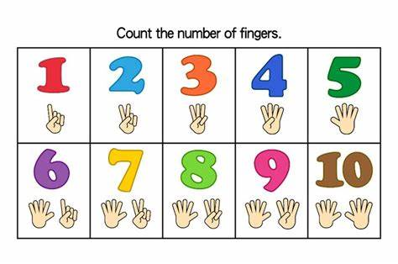

Children learn physical skills all the time. Most of the skills we can learn and practise at school but some we need help from adults outside of school.

**Challenge: Can you walk upstairs or climb up apparatus/climbing frames using alternate feet?**

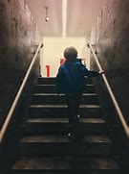

Please complete one challenge per week and upload pictures to Tapestry each week when you have completed this.

Please check Tapestry regularly for updates and extra learning activities for your child and post pictures of these.

Thank you for your support. 

Nursery Homework

Autumn 2

We have been learning about words that rhyme. E.g. cat, hat, mat, bat.

**Challenge: To continue to name other rhyming words to dog, snake, fox and wall.**

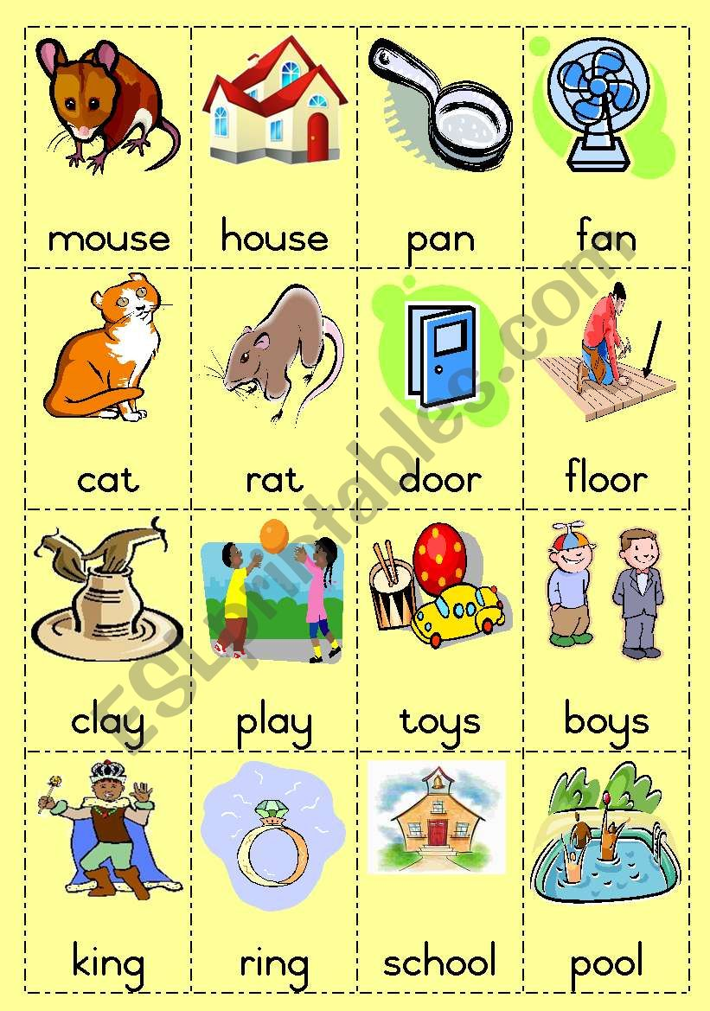

Nursery are learning about day and night. We are learning about how shadows are formed.

**Challenge: To make a shadow puppet.**

