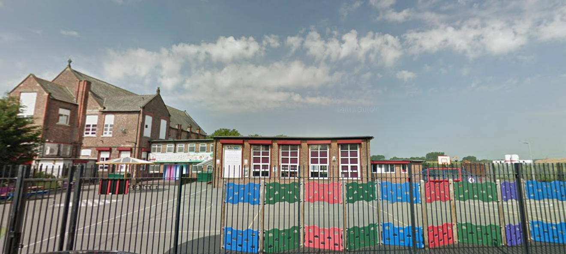

‘Keeping Christ at the heart of all we do’

**St. Sebastian’s R.C. Primary School**

**Curriculum Overview**

**Year 5 Autumn**



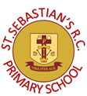

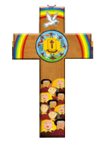

|  |  |
| --- | --- |
| **Class Information**  Reading – regular reading at home is essential to build up your child’s vocabulary and pace. Please try to read for at least twenty minutes each evening and sign your child’s reading record daily.  Times tables – the rapid recall of multiplication facts is vital for accessing the mathematic curriculum. Regular practise at home is invaluable to prepare your child for lessons in school. Children should access TTRS from home daily.  P.E – our P.E days are Tuesday and Wednesday. Children need to arrive at school wearing their PE kit and suitable footwear. | |
| **English** | **Narrative:**  In our narrative writing, we will study the book, ‘The Nowhere Emporium’ and use it to produce a piece of narrative writing.  **Non-Fiction:** We will study and write a chronological report based on Emperor penguins. |
| **Maths** | As mathematicians, we will focus on the place value up to 1,000,000. We will compare and order numbers and practice rounding numbers as well as investigating Roman numerals. We will move onto multiplication, including finding prime numbers, factors and square/cubed numbers. The children will then begin to compare, order, add and subtract fractions. |
| **Religion** | As Christians, we will begin the year by looking at how God has made everyone individually and uniquely. Following this, the children will investigate a sensitive theme. The experience of ‘family’ in society today is varied, with many joys and sorrows. Whatever the experience, family still remains the first place for growth and development, the basic social unit. What does the word ‘family’ mean to you? What people do you associate with ‘family’? What joys and sorrows do you remember of family life? The children will then move on to study hope and life choices. |
| **Science** | We will focus on the changes that happen to human beings as they develop to old age by looking at the life cycle of a human being. They will investigate the development of babies and compare the gestation period of humans and other animals. They will learn about the changes experienced during puberty and why these occur. The children will then move on to Earth and Space, where they will investigate the properties of the solar system, including the moon, sun and the Earth’s rotation. |
| **Geography** | The children will study mountains, including the biggest mountain ranges across the world and the highest peaks of the UK. We will particularly focus on the Himalayas and discover what mountain life is like. Additionally, the children will learn to read maps efficiently. |
| **History** | As historians, we will investigate the Kingdom of Benin from a range of historical sources. We will identify the characteristic features of the society and period through historical enquiry. The children will deduce information by looking at and interpreting artefacts. |
| **Design & Technology** | As designers, the children will analyse mechanical systems and understand the processes behind them. The children will work to produce their own mechanical system. |
| **Art** | As artists, we will explore the symbolic meanings behind the art and design of the ancient Benin civilisation. We will work in 2D form to create our own designs influenced by the art and craft of this African kingdom. |
| **Computing** | We will focus on internet safety and how to stay safe when playing online games. We will also be investigating coding by using numbers and spread sheets. |
| **Music** | As musicians, the children will learn to play some chords on the ukulele. They will also begin to read basic music. |
| **PSHE** | This term, we are focusing on RHE (relationships and health education), specifically looking at how the children are growing and changing and how this links to our emotions. We will also be looking at the British values of Democracy. |
| **PE** | This term, the children will learn the rules of dodgeball and apply this to a game. Moving on, we will learn and develop our dance skills. The children will be taught by a physical education specialist. |